 | RESEARCHER INFORMATION
 | Name | Dr Erik Schaltz
 | Present Position | Associate Professor , The Faculty of Engineering and Science | 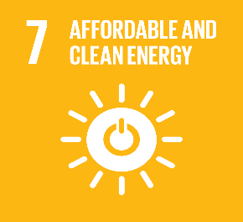
 | Organization | Aalborg Denmark
 | County | Denmark
 | Email | esc@energy.aau.dk
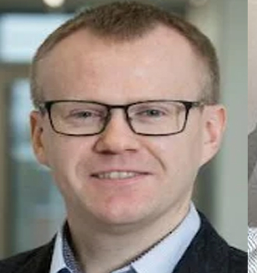
RESEARCH AREAS and ACHIEVEMENTS
Mechatronic Systems, Batteries, E-Mobility and Drives
14 projects, 51Journal article, 46 Article in proceeding, 11 Conference article , 16 pub in press and media
Best Paper on Ecological Vehicles and The ITS Outstanding Application Paper
SHORT SUMMARY OF COMPLETED WORK | OUTPUT RESULT
Lithium-ion batteries are being implemented in electric vehicles, to improve battery cells with a great life cycle. To avoid disconnection among battery pack ingredients and deformity during cycling, compacting force is exerted to battery packs in electric vehicles. This investigation exhibits a comprehensive description of the experimental setup that can be used for battery testing under pressure to consider lithium-ion batteries’ safety, which could be employed in electrified transportation.  Fuel cells have been applied to DC/DC converters where the reliability and lifetime are of high importance. In this work, a lifetime prediction model is applied for the power semiconductors, which are used in a Boost, Z-source and Y-source fuel cell DC/DC converter, in a fuel cell hybrid electric vehicle application. The lifetime estimation results shows for this study that the Z-source converter has a longer lifetime compared to the conventional boost and Y-source converter.  Lifetime Prediction of Converters in a Fuel Cell Hybrid Electric Vehicle Application , eVolution2G - V2G: Innovative Vehicle to Grid model for electric mobility deployment in Europe | 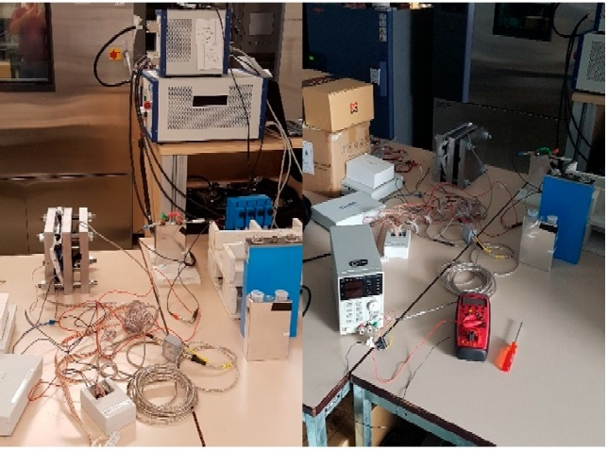  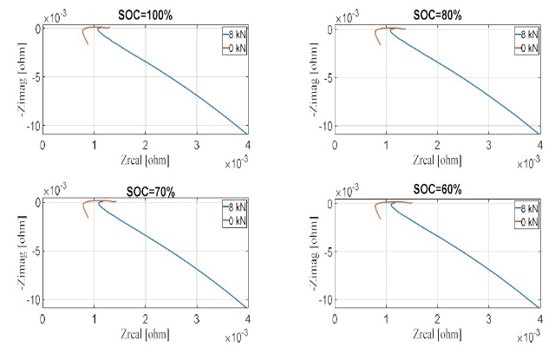
PUBLICATION PROOF & SCOPUS AUTHOR PAGE LINK
https://vbn.aau.dk/en/persons/113152/publications/
https://www.scopus.com/authid/detail.uri?authorId=25927513700

